**SAN ACADEMY GROUP OF SCHOOLS**

**PALLIKARANAI**

**OBSERVANCE OF INTERNATIONAL DAY AGAINST DRUG ABUSE**

International Day against Drug abuse is observed on June 24 at SAN premises. It is an expression of its determination to strengthen action and cooperation to achieve the goal of an international society free of drug abuse.

A special assembly was conducted on 24th June, 2022 for class 9 to 12 students in San Academy, Pallikaranai on a topic of International Day against drug abuse. The excellent part of this assembly is the oath taken by our students on "say no to drugs" and **Chase your dreams, not drugs**. Cool kids don't do drugs. Don't let drugs to own you. Drug abuse is of no use.

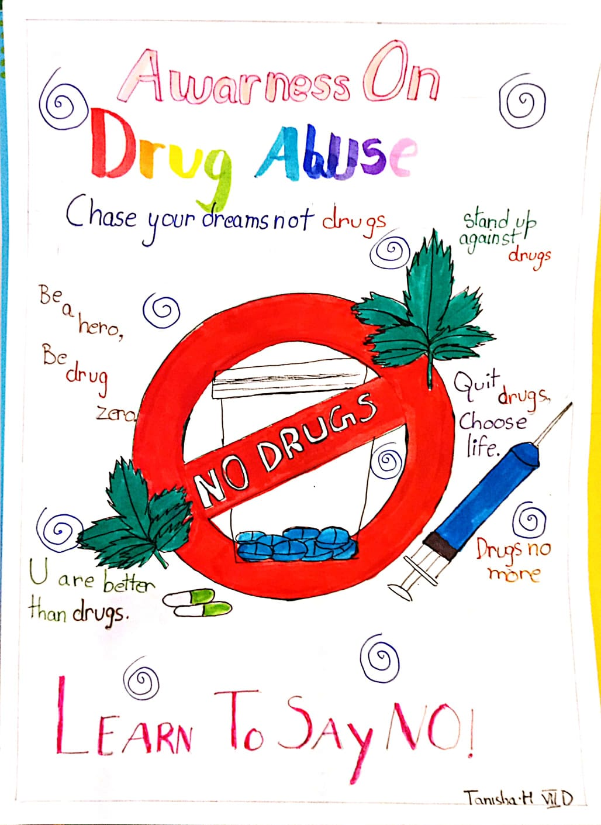. This was a very healthy awareness program among the school students as it exhibits the importance of observing this international day against drug abuse. The student volunteers themselves to give the importance if this day celebrated and about the organization is working behind this. Poster making and slogan writing contests were undertaken by our students to create awareness against drug addiction. Our principal, Mrs. Hemalatha, gave an informative speech about drug use and abuse. It was a great opportunity to take a pledge against drug abuse.

